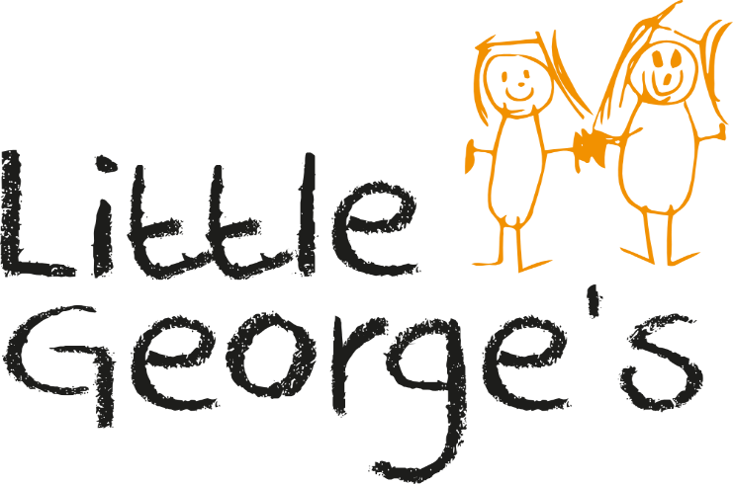

Springwest Academy
Browells Lane
Feltham
Middx
TW13 7EF
020 8831 3049
07394399034

Parents
Information
Pack

Welcome to Little George’s

This parent pack has been designed to introduce you to our nursery, it may also answer many of the questions that you have regarding the nursery’s provisions. We would recommend that you pay a visit to the nursery to see for yourself the nurseries provisions and to meet all of the team. At which time will we be very happy to clarify any further queries you may have.

Little George’s is a 38 place friendly and caring private day nursery, which caters for children aged between 0 and 5 years old. There is a separate baby room which has specifically designed to cater for under two’s and runs alongside the preschool provision. The nursery provides a stimulating, warm, safe environment where children have a variety of experiences in which to learn and play.

The nursery is open Monday – Friday from 8.00am – 5:00pm all year round expect bank holidays and the 5 non bank holiday days between Christmas and New Year.
Sessions available 8.00 – 5:00 Full day
8:00 – 12:30 (morning session without lunch)
8:00 – 2.30 (morning session with lunch)
12:30 – 5:00 (afternoon with lunch)
2:30 – 5:00 (afternoon without lunch)

In England, working parents can currently access 15 hours of free childcare per week for their 3 and 4-year-olds, and some eligible parents can get an additional 15 hours, making a total of 30 hours. From September 2025, eligible working parents will be able to access 30 hours per week for children aged nine months to school age.
You will use your funding over the full year and your hours will be stretched. Sessions are available in the hours outlined above, if you are using you EEE funding over the lunchtime sessions please note your funding does not include the cost of lunch which can be purchased or alternatively you may bring a packed lunch.

There is also funding available for children aged two, however there is a criteria, this funding is called Early Learning Entitlement for two year olds. Please ask for further details from the nursery manager.

Admissions
Parents that wish to request a nursery placement are required to complete the booking form at the back of this information pack. Once completed this should be returned to the nursery as soon as possible. Once a booking form has been completed the nursery will confirm with you if your placement has been secured, if it is within the coming 6 weeks or if you have been placed on the nurseries waiting list in writing and an allocation will be made.

Settling in procedure
Three weeks prior to your child’s start date the nursery team will contact you to arrange a date to come in to complete your child’s paperwork and to settle them in. Every child is required to complete a settling in period, the length of the settling sessions will depend on the individual child and their needs.

The parent will be required on the first settling in session to visit the nursery with their child and stay with them for at least half an hour. On this visit the key person and parents will complete all relevant paperwork, such as the child’s profile form, individual routines, authority to collect letter and permission slips. Settle in times and dates for the child to visit for short periods increasing in time will also be arranged, depending on both the child’s and parents needs.

On the child’s first day it will be arranged that the child’s key worker will be on the relevant shifts to great the child when they arrive until the child is settled. It is important that good parent communication is achieved at this time to ensure the smooth transition for the child. For the child’s first week at nursery you may be asked to drop your child a little later and collect a little earlier to allow them to become accustom to their new environment and to avoid them from becoming distressed when other parents drop off and collect their child. It is vital that your child feels comfortable and confident in their new environment.

Early Year Educator
At Little George’s the staff team is predominantly comprised of highly experienced and qualified members with Early year level 3 or the equivalent, all staff continue to build on this with further training to a higher level and leadership and management. The nursery believes in personal development and training and follows a training programme, which includes training from both internal and external agencies. All staff are required to hold certificates in First Aid and Food Hygiene.

We have a minimum staff ratio of (staff:children) 1:3 for children under 2 years, 1:4 for children aged 2-3 years and 1:8 for children aged 3-5 years. However the nursery aims to provide a higher staff:child ratio throughout the sessions..

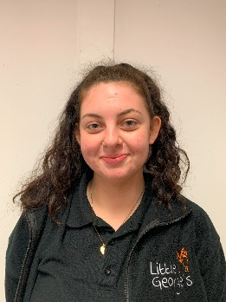





Tracey Monk Nursery Manager
Krystal Didd Nursery Practitioner

Muneeza Sheikh Nursery Practitioner
Lorraine Pearman Nursery Practitioner
Petya Tomova Deputy Manager

Key person
All children are allocated a key-person, your key-person has a special responsibility for your child, they will be introduced to you and your child on your first visit and will do the initial induction in to the setting. They will also ensure that the needs of your child and parent are met and develop a good line of communication with you. They are responsible for liaising with you regarding your child’s progress, setting up and reviewing your child’s individual daily routine and revising play plans.

The Curriculum

The nursery has a detailed learning curriculum for children, which is based on the 3 Prime and 4 Specific Areas of learning as outlined by the ‘Statutory Framework for the Early Years Foundation Stage’. We particularly focus on identifying children’s individual needs.
The areas of learning are as follows; -

Three Prime Areas:

- Personal, Social and Emotional development.
- Physical Development.
- Communication, Language.

Four Specific Areas:

- Literacy
- Mathematic
- Understanding the World
- Expressive Arts and Design

The nursery has a detailed learning curriculum, and the framework focuses on the child’s individual learning. All children have a range of different experiences, skills and interests when they join us so our activities are informed by observations on the children and are planned with each child’s interests and abilities in mind. The nursery also supports the development of the children by introducing new concepts and knowledge. We ensure the children have the opportunity to interact with a consistent adult at frequent intervals throughout their day.

A copy of the Nursery Curriculum Document is available for parents, please ask a staff member for your copy.

Alongside the curriculum we have lots of programs running to help develop children’s social skills, understanding of the natural environment and self – development, as well as physical and mental well being.

Forest Schools
Forest School is a Danish concept that develops learning by experience. The philosophy of forest schools is to encourage and inspire children through positive outdoor experiences. At Little Georges our Forest School Leaders focus on personal development and the individual learning styles of the children. By participating in engaging, motivating, and achievable tasks and in activities outdoors your child will develop sound emotional and social skills.

PALS
Playing and Learning to Socialize is an Australian research based Social Skills program designed by clinical psychologist and early year’s teachers to use in early years settings.
At Little Georges Day Nursery PALS programme is embedded within the weekly small group activities The PALS social skills program shows children constructive ways to solve problems that may arise in social situations, they learn to share, take turns and how to express emotions, this is done through stories acted out by puppets, role-play and songs. The programme is designed to help children develop social skills helping them to develop trusting relationships and friendships. A leaflet will be placed in your child’s tray each week explaining what your child has done during the session.

Physical Literacy
This programme encourages children to become more physically active, and to engage in a healthy programme of exercise and motor development. The nursery takes this programme very seriously and encourages parents to take home resources to complete activities at home. This programme also runs parallel to the nurseries Healthy Eating Programme, where by we believe a healthy diet is essential to support healthy development in all areas.

Letters and Sounds
The letters and sounds programme helps to develop children’s understand of how words and language is formed. It enables them to develop a solid base from which to develop their reading and writing skills. The programme looks at rhyming words, alliteration, individual letter sounds, blending, diagraphs, trigraphs.

All children have access to the Sensory Sessions and Physical Literacy programmes. The Letter and Sounds, PAL’s and Forest School programme are aimed at children aged over 30 months.

Little Beginnings
The unit has been specifically designed to cater for children under 2 years old. The daily routine is flexible to meet the needs of each individual child, whilst providing a balanced and stimulating day allowing time for sleep and relaxation within the designated sleep area. We provide a selection of cots and toddler beds for all children with their own individual bedding.

The main play area consists of carpet and lino allowing the babies to explore the room around them, having access to small world toys, construction toys, natural holistic play equipment, books, puzzles and soft tumble toys. The lino area is used for messy and sensory activities where they can paint, stick and use play dough.

Little Beginnings follows the guidelines as outlined in the Early Years Foundation Stage and sets out clear learning opportunities for each child, starting with what they can already do and building on this to extend it further, for example by supporting or encouraging babies trying to stand or walk, by planning and offering toys and furniture for cruising.

Little Learners
The main room is divided up into different defined areas including an imaginative role-play area, cosy corner, mathematical area, a creative station, carpet areas for large construction and small world play. All areas allow children to ‘bump into books’ giving an opportunity to extend and develop their learning and knowledge.

The staff and children follow a flexible daily routine in which, the children are provided with a caring, fun, relaxing and stimulating learning environment. We provide a well-planned and resourced learning environment to take learning forward and we provide opportunities for all children to succeed in an atmosphere of care and feeling valued.

We have organised the routine so there is time and resources to give the children age appropriate opportunities to make independent choices, we offer a free flow system throughout the day where children can choose to play inside or outside as well as which activities they would like to take part in. To support children’s independence and individual learning we encourage children to choose which activities they would like to participate in throughout the day, this not only enables them to have more choice but also allows them to spend longer at activities if they so wish in order to complete something or feel satisfied.

Close links are formed with the parents to offer support with areas such as, toilet training, learning to share and learning about our environment. These are particularly important stages and parents are positively involved with these programmes.

Parent’s activity day program
At Little George’s parents are invited to participate in different activities throughout the year.
A sample of the types of days we arrange is shown below;
*Cooking session *Pyjama day *Creative sessions *Multicultural concert
*Christmas concert *Parents evenings *Easter party *Weekend family trips * Grandparents Day

Equality of opportunity
At Little George’s we are committed to equal opportunities towards all children, staff and visitors. It is our intention that the children should be able to enjoy the full range of activities, play equipment and materials without discriminating against physical, educational or sensory disability, race, religion or ethnic origin. A copy of the nurseries Equal Opportunities policy is available on request and is displayed on the parents information board.

Special Educational Needs
At some time in every child’s life they may encounter some difficulty with either behaviour or learning. At this time additional support may be required to assist the child in their particular needs. We at Little George’s believe in treating children as individuals and providing for their specific needs, by providing them with regular reviews, assessments and observations. A copy of the nurseries Special Educational Needs policy is available from the nursery on request as well as being on display on the parents notice board.

Behaviour management
Boundaries of acceptable behaviour need to be established for a clear reason and explained to the child. Behaviour will be managed by the giving of praise and encouragement to help succeed and want to behave in an acceptable way.
A copy of the nursery Behaviour Management policy is available on request.

Meals and rest periods
The nursery provides 3 meals a day, a mid morning snack is served at 10am, a two course lunch is served at 12.30pm and a light tea is served at 3:30pm. Even though the nursery does not provide breakfast there is a table is available for those wanting to bring some in before 9am. All meals are sociable relaxed occasions and children’s birthdays are celebrated with a cupcake made by the nursery.
The nursery currently holds a 5-star rating from the environmental inspection department for its kitchen and procedures.
Parents are required to provide all formula milk until the child can have cow’s milk which the nursery provides. A quiet area will be made for any breastfeeding mothers who choose to continue feeding their child.

+Nursery uniform
The nursery has a uniform of a nursery t shirt and sweatshirt, although this is not compulsory it is highly recommended, parents can purchase a t-shirt and/or sweatshirt at cost price from the nursery. We do suggest that children wear comfortable and suitable clothing and we recommend that children do not wear their best clothes as paints and messy activities are accessible daily. Any removable clothing should be labelled clearly with the child’s name e.g. hats coats gloves etc. and a coat provided daily as children regularly go out to play. We also request that children wear appropriate shoes to nursery such as Velcro trainers or shoes that they can put on themselves to help to promote their independence skills. Flip flops are not recommended as they can be hazardous when running.

Working in partnership with parents
Little George’s Day Nursery staff work closely with parents in partnership. To ensure this staff will discuss with parents their individual child’s progress on a daily basis. We stress to staff that it is their friendly contact and communication with parents, which is essential to the happy atmosphere of the nursery.

Parents must feel they are able to visit the nursery throughout the day. The nursery staff will make them feel welcome at all times. We will endeavour to ensure that we can accommodate any particular wishes parents may have for their child. All records kept on the children are always available for parents to see.
The parents are able to discuss on a daily basis their child’s progress, both verbally and through their daily contact books. Other means of parental access to information are available through regular newsletters, parents evenings twice a year, and various reports available for parents.
The nursery manager is always available to discuss matters relating to any individual child or indeed issues relating to nursery both on a formal and informal basis.
Parents can request a meeting with either their key worker or a more senior member of staff at any time that is convenient to both parties. The discussion that takes place will be treated completely confidentially and all parties will agree any further action if appropriate.

Little George’s believe that working in partnership with parents is paramount for the happiness and well being of the child. We promote parents activity days each month so as to provide a delightful environment for staff and parents to establish bonds. Notification of parent activity days and trips are to be found in the monthly newsletters.

Health and safety
Our policy is to provide and maintain safe and healthy working conditions, equipment and systems of work for all our employees and children in our care, and to provide such information, training and supervision as they need for this purpose. We also accept our responsibility for the health and safety of other people who may be affected by our activities. A full Health and Safety policy and risk assessment is available to all parents on requests.

Security
The nursery entrance is operated by an entry bell on the outside fence, parents are required to buzz and wait for a member of staff to allow them access. Children are required to be signed in and out of the nursery in the signing book at the front desk. If anyone else is to collect your child then they must be listed on the collection consent form you fill in when your child starts the nursery. If we do not know the person collecting your child please provide a password, clear description or photograph.
If we do not know the person who has turned up to collect your child we would not allow them to take your child and you will be contacted straight away.

Toilet training
Toilet training is an important element in becoming independent; we will happily work with you on a program to assist your child in becoming dry. If your child is still in nappies you will be required to provide them along with wipes or cotton wool and any creams used on a regular basis, your key-person will inform you when the supply is running low.

Medication and illness
We request that parents keep their children at home if they are feeling unwell. If your child has an infectious illness we have a duty to inform other parents within 24 hours or as soon as possible, parents will be required to keep their children at home for the period of time as outlines in the infectious illness guidelines. If a child has been prescribed antibiotics we recommend that they are excluded from nursery for 24 hours to allow time for the antibiotics to work.
Other medications that are prescribed by the doctor are able to be administrated by one of our first aiders; parents will be required to sign for this in the medicine book. Written instructions must be given for the use of regular medications such as inhalers for asthmatic children. A more detailed policy is available on request.
Unfortunately, no fees will be refunded for days taken off due to illness.

Nursery fees
The fees for the nursery sessions are outlined in the fee’s schedule at the back of the information pack. Nursery fees are payable 4-5 weekly in advance and are due on the 1st of the month.
One month’s fees are payable on commencement, this covers the first month of attendance at the nursery. In the event of your child not commencing at the beginning of a month, then we will reduce the next month’s fees by the number of days not attended in the first month.

A deposit is required upon starting the nursery; this is returned upon leaving provided the correct notice period is given. A deposit of £50 is required for a part time placement and £100 for a full time placement. No deposit is required if accessing funding hours.

The nursery is open Monday to Friday all year except English bank holidays and the period of 5 working days between our Christmas party and new year (you are not charged for this period). Monthly fees are calculated by a 51 week year. There are no reductions for your personal holidays or sickness. The nursery closes for two inset days per year and you will be given prior notice as to the dates of these closures. There is no reduction in fees for inset days.

Bookings can only be confirmed on receipt of the nurseries booking form.

Notice period
One full month’s notice of your requirements must be made in writing to the nursery. If you require changing your days and times then we will endeavour to do this as soon as availability allows, if required within the one month period, there may be delays if the days or times are fully booked. In circumstances where changes of days and or times lead to a lower monthly fee then the higher amount will be paid for the 1 month notice period.
Plans for your child leaving the nursery should always be discussed as far as possible in advance and a minimum of the one months notice in writing that is required, otherwise 2 months fees must be paid in lieu of notice.

Further information
For further information and to visit the nursery please ring one of the nursery team on 0208 831 3049.

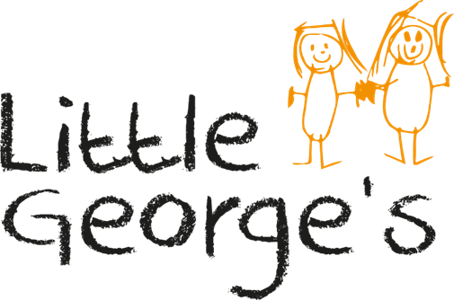

Springwest Academy
Browells Lane
Feltham
Middx
TW13 7EF
0208 831 3049
07394 399034

BOOKING FORM

Childs Name_____________________________________________________
Surname_________________________Age____________DOB_____________
Address_________________________________________________________
__________________________Postcode____________Tel No_____________

Mothers name _____________________________Daytime No______________
Mother’s Email address……………………………………………………………………………………………………

Fathers name______________________________Daytime No______________
Father’s Email address………………………………………………………………………………………………………………..

Days required per week (please circle)
MONDAY TUESDAY WEDNESDAY THURSDAY FRIDAY
Hours required from…………………………………….……………..until……………………………………….………..
Commencement date……………………………………………………………………….………………………………………..
Please enroll my child at Little Georges Ltd to commence on the above date.

I understand that one months notice must be given to the nursery in the event of my child needing to reduce days/hours at the nursery or when withdrawing from the nursery. In the event of one months notice not being given I undertake to pay the months notice prior to my child leaving nursery (days of for sickness or Holidays including bank holidays are still payable to the nursery during the time my child is at the nursery and are payable during the one month notice period)
I understand that the nursery operates an open access to information policy and I am welcome during opening hours to view the policies and procedures under which it runs. I am also aware that parents evenings are held approximately twice per year and the manager is happy to arrange meetings to discuss any matters concerning your child at any mutually agreed time.
I / we have been provided with details of the settings policies and procedures, including the information sharing procedures and understand that there may be circumstances where information is shared with other professionals or agencies without my consent.
I understand that the children are taken for walks, visits etc. off the premises and I give my permission for my child to be included in such outings.
I also give my permission for the staff to administer prescribed medication with my signed consent. I am aware that the nursery is unable to care for sick children and I will collect my child whenever the nursery feels it is necessary.
I understand that I am required to pay a deposit of £……... which will be refundable upon my last months fees providing the full notice period has been given in writing. I understand that there is no reduction in fees for sickness and holidays and bank holidays.
Little George’s Ltd is not responsible for any loss in toys, clothes, paint stains or damage to clothing. Please ensure your child is dressed appropriately for their day.
I understand that I am required to inform the nursery of any changes in the child’s details e.g. change of address. It is particularly important to ensure that emergency contact numbers are always updated.
I give consent for the setting to share development summaries / trackers to the next provider/ school my child may attend. I give consent for the setting to share confidential information to outside agencies if required as outlined in the information sharing policy.
I understand that that all adults, including parents are expected to adhere to our behaviour management policy. If parents display any unacceptable behaviour their child’s place in this setting will be seriously compromised.
I understand that if the nursery is closed due to any reasons beyond its control e.g adverse weather conditions or power failure then I agree to pay the nursery fees for that session.
The nursery will be shut for two days per year for inset days which I am required to pay for, I will be given at least two months’ notice of the dates.
All other terms and conditions are as outlined in the attached parents information pack.

Signed (parent/guardian)………………………………………………………………………………………………………………..
Print name………………………………………………………………………………………………………………………………………….
Date…………………………………………………………………………………………………………………………………………………….

